# Steps to apply Mendix Operator License for the application.

Step 1- Use PowerShell CMD then activate environment subscription i;e DEV/QA/PROD and set context of namespace accordingly.



Step 2- Put the operator license in PowerShell CMD

 $license_key=""

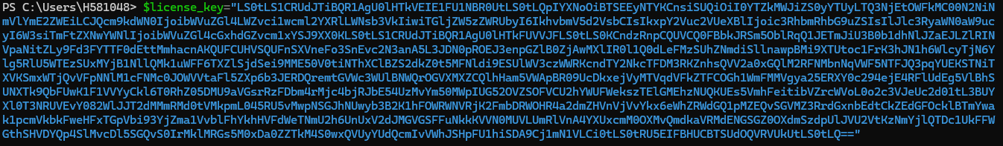

Step 3 -Please ensure that you **change the name of license** to identify as per app name as highlighted below-

kubectl -n mendixplatformqa create secret generic **npimendix-operator-license** --from-literal=licensekey=$license_key



Step 4- kubectl -n mendixplatformqa patch operatorconfiguration mendix-operator-configuration --type=merge -p '{\"spec\": {\"licenseKeySecretName\": \"**npimendix-operator-license**\"}}'



Step 5- Scale the operator deployment

kubectl -n mendixplatformqa scale deployment mendix-operator --replicas=0  
kubectl -n mendixplatformqa scale deployment mendix-operator --replicas=1